**CS691 - Computer Science, Fall 2022**

**Project Initiation Document**

**Project: QR Yummy!**

**Project Manager: Mogal Zubair Ahmed Baig**

**Start Date: 9/13/2022**

**Completion Date:-------**

**Table of Contents**

Document Purpose 4

Background to the Proposed Work 4

Vision 5

Project Objectives 5

Project Scope 5-6

Business Case 6-9

Assumptions 9

Constraints 10

Risk Management Strategy 10

Deliverables 11

Stakeholders 11

Project Team 12

Project Plan 12

Project Controls 12-13

Communication Plan 13

**Document Details**

| Version | Modifications | Author | Date |
| --- | --- | --- | --- |
| 1 | Initial PID Document | Project Manager | 9/25/2022 |
| 2 | Updated PID Document | Project Manager | 10/10/2022 |
|  |  |  |  |

**Approvals**

This document requires the following approvals:

| Name | Role | Signature | Date | Version |
| --- | --- | --- | --- | --- |
| Dr.Yuri Chernak | Professor |  | 9/25/2022 | 1 |
| Dr.Yuri Chernak | Professor |  | 10/10/2022 | 2 |
|  |  |  |  |  |

**Distribution**

This document has been distributed to:

| Name | Role | Date of Issue | Version |
| --- | --- | --- | --- |
| Mogal Zubair Ahmed Baig | Project Manager |  | 2 |
| Gayathri Raj Patel | Product Owner |  | 2 |
| Chitra Lekha Yatham | Lead Business Analyst |  | 2 |
| Divya Mohan Kumar | Lead Developer |  | 2 |
| Soumyadip Chatterji | Developer/DBA |  | 2 |
| Rob Alberti | Lead QA Analyst/Tester |  | 2 |

# Document Purpose

This document has been created to mention the basic information which is required to manage the project.This document will state the vision,tasks, roles, responsibilities , cost and deliverables of the concerned project QRYummy!

This Project initiation document also states the important factors such as:

>Details of proposed work and the implementation of QRYummy! web application Project.

>Details of the roles and responsibilities.

>Details functions and activities.

>Explanation of the processes.

>Details of the communication plan between the team and the stakeholders

>Quality records,risks,project controls and exceptions

These sections of this document are dynamic and could potentially change over the time of the project and those changes will be recorded in this PID document.This document will be revised each time whenever a decision or any change is updated in the project.This PID document will also be used in the end of the project to check whether the project was managed successfully and also to check whether all the deliverables are satisfied in time.

# Background to the Proposed Work

Through “QRYummy!” web application, we will be able to save most of the waiting time in the hotel and also the unnecessary time of interaction with waiter, as time is most important factor, our project is mainly focused on saving lot of time and making things easy. This web application is particularly designed to order food via online using their mobiles or any internet connectivity enabled device when sitting in the restaurant instead of waiting for the waiter.

The main purpose of this project is to reduce the unnecessary waiter interaction time, and making the day to day life easy, so that as soon as the customers arrive they can be able to choose the food they want to eat and also if they aren't satisfied with the descriptions provided for each food variety then they can also call the waiter through the web app itself, so anyway it would be more useful and effective for the hotels to serve the customers within less time , and also the by this web application they can improve the customer turnover too.

# Vision

Now a days, food is the most trending business and the most demanding upon all of the businesses,so by providing this application to all of the restaurants and spreading it , will make their business more profitable by circulating more customers than usual.Customers will also be benefited by this application as they will have access to everything to order and they can also start the dining as soon as they enter and scan the QR code.Our product will not only solve the time consuming factor but also create a smart and modern way of ordering food in hotels.

# Project Objectives

> To create a website including the functionalities of ordering food online while dining, suggesting the most famous variety to taste based on the location, delivery services and paying online.

> To create a user-friendly interface.

> To add varieties to suggest customers

>To promote their hotel and their popularity

>To communicate with the same branch of hotel networks

# Project Scope

Our scope is to create a online dining menu with QR code with following categories :

Functionalities:

> End user will be able to order online without waiting for the waiter in the hotel

> End user can be able to read the speciality and description of each food item

> End user could be able to pay from the site

Technicalities:

> To apply the best UX/UI practices.

> To decide what DB to use.

> To decide what SDLC methodology to implement.

> To discuss roles and responsibilities in a team.

> To install the required software.

> To ensure that the team members have necessary skills.

> To set up development, staging and production environments.

# Business Case

This section will justify the project so the board can then decide if it gets to go ahead. Benefits should be quantified and balanced against the cost and timing being estimated during the creation of the project plan.

Large projects may summarize and include a link to the full business case.

| **Application Name** | QR yummy! |
| --- | --- |
| **Type of business model** | Crowdsourcing:  Will provide the service to customers and collect the data from the selections of customer  Advertising:  Will advertise as an additional income of source to support the project |
| **Target audience of external users** | Customers in restaurants |
| **Groups of internal**  **stakeholders, business users** | ***Indicate who will be using the system.***  **Do we need a product development group?**  yes  **Do we need a sales group?**  no  **Do we need a finance group (accounts payable, receivable)?**  no  **Do we need a customer support team?**  no  **Do we need an advertising management group?**  Yes |
| **Value propositions** | **What value do we deliver to the customer?**  The main goal of the platform is to eliminate the waiting/ interruption time caused by the waiters.  **Which one of our customer’s problems are we helping to solve?**  1: Waiting for the waiter to show up.  2: Interruption by the waiter with such questions like “Are you ready to order?”  3: Payment time delay.  **What bundles of products and services are we offering to each**  We are providing a live chat bot if a customer happens to find difficulty in ordering a meal or to know the best combo food to order. Also, there will be a button to notify the restaurant front desk employees to send their waiter to a specified table. |
| **Key resources** | **What Key Resources do our Value Propositions require?**  Team of developers to create and support the platform.  Team of marketing to promote our web app platforms.  **Our Distribution Channels?**  Web application site  **Customer Relationships?**  The nature of customer relationships is of a self-service character.  **Revenue Streams?**  Ads, grants, and donations. |
| **How the system is used** | Scanning the QR code, navigating into the menu page and can order followed by the payment directly from the site. |
| **Revenue generation, Revenue streams** | 1. Ads 2. Community funding 3. Data collection |
| **Key Partners/Suppliers (Stakeholders)** | A strong initial base of local restaurants as well as a few hotels. |
| **Expected Benefits** | Allowing customers to order meals without waiting in line could help to save a lot of time without having any interaction with waitresses and instead of having all ordered menus written on paper everything is digitalised. |
| **Known Prototypes** | This is the only prototype currently existing  [**https://www.upmenu.com/**](https://www.upmenu.com/) |
| **Front-end Technology** | React  CSS |
| **Back-end, Database Technology** | Python, AWS RDS (MySQL). |

# 

# 

# 

# 

# 

# Assumptions

This section will include assumptions made before the requirements specifications have been documented:

| Assumption | Validated by | Status | Comments |
| --- | --- | --- | --- |
| Participation Time | All team members | Completed | All All members have decided to provide 6 hours  per week to this project. |
| Team Meeting | Project Manager | In Process | Project manager will schedule one – two meetings every week. |
| Team Work | Project Manager | In Process | Manager will keep details of all Modules and will assign ‘Single or Team’ work on specific modules |
| Skill Requirement | All team members | In process | Each team member in a meeting should be involved in the process. |
| Project Resources | Business Analyst | In process | Checks all requirements and resources. |
| Team Members will stay the same | All members | Completed | All All members have decided to take Project-2 i  in next semester. |

# Constraints

The main factors to be considered during the delivery of this project are:

>As this is a team project , there will be different schedules and different availability of time for each person,so each person has to schedule time for this project and as a team , everyone have to collaborate with all other teammates and have to discuss the work with everyone of the team member

>We have to make sure that the application should be delivered within time and it fulfills all the requirements as stated for this project.

# Risk Management Strategy

This section will include the risk mitigation and management techniques and strategies that will be applied to the project. This may be presented in the following format:

| Risk | Probability | Impact | Mitigation Method |
| --- | --- | --- | --- |
| Member unavailability | High | High | All the team members should get to know what activity is going on regarding their particular roles and also if any of the member is unavailable at the particular time before delivery, one member should be replaced in that role temporarily |
| lack of skills | medium | medium | All the team members should practice their practical development skills in the beginning of the project itself to avoid upcoming issues |
| project management | medium | medium | Everyone in the team should be organized and follow the commands set by the manager in order to avoid project delay |
| project requirements | high | high | Though the task is assigned to everyone of the team member, but its necessary to confirm whether , each and every member of the team understood the requirement or not before misleading. |

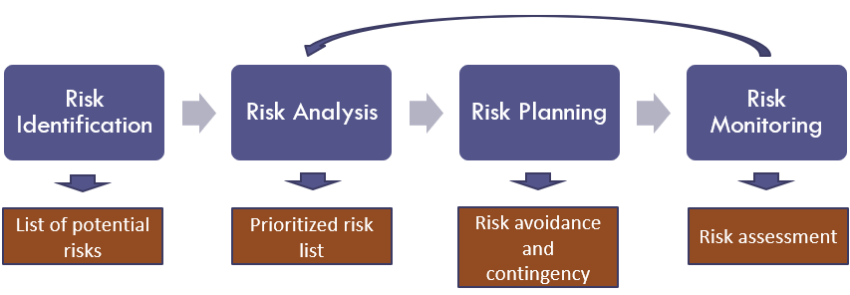

# Deliverables

This section should include the main deliverables and outcomes the project is expected to achieve. It may be presented in the following format (see the project delivery schedule on Blackboard):

| No | Artifact Name | Responsible Party |
| --- | --- | --- |
| 1 | Project plan | Project Manager |
| 2 | PID document | Project Manager |
| 3 | BRM Diagram; User Roles | Product Owner |
| 4 | Context Diagram; System Interface Table | Lead BA |
| 5 | Architecture Diagrams (Logical, Process views) | Lead Dev/ BA |
| 6 | Business Requirements | Product Owner |
| 7 | RCT (includes func. decomp., suppl. reqs) | Lead BA |
| 8 | Use-Case Diagrams (UML) | Lead BA |
| 9 | Activity Diagram (UML) | Lead BA |
| 10 | Data-flow Diagrams (logical, physical) | Lead BA |
| 11 | Functional Requirements (user stories) | Lead BA |
| 12 | Class Diagrams | Lead Dev |
| 13 | Sequence Diagrams | Lead Dev |
| 14 | ER Diagrams (conceptual, logical) | DBA |
| 15 | Table Specifications (Data Dictionary) | DBA |
| 16 | Source Code sample (part of Demo) + GitHub repository slides (images) | Lead Dev |
| 17 | Test Plan document | Lead QA |
| 18 | App Demo (recorded), Presentation PowerPoint | All |
|  |  |  |

# Stakeholders

*Project Stakeholder – the party who is involved in or affected by your project.*

This section will include a list of all known stakeholders and their interests in the project. It may be presented in the following format:

| Stakeholder | Interest |
| --- | --- |
| Banking/CC companies | Provides payment options for items on the product |
| Users | The end users of the product which include people and or businesses using it. |
| Restaurants/Hotels | The businesses that will have their menu hosted and food/drinks displayed on the product. |

# Project Team

This Project team include the following roles:

> Project Manager - Mogal Zubair Ahmed Baig

> Product Owner - Gayathri Raj Patel

> Lead Developer - Divya Mohan Kumar

> Developer/DBA - Soumyadip Chatterji

> Business Analyst - Chitra Lekha Yatham

> QA Lead/Tester - Rob Aliberti

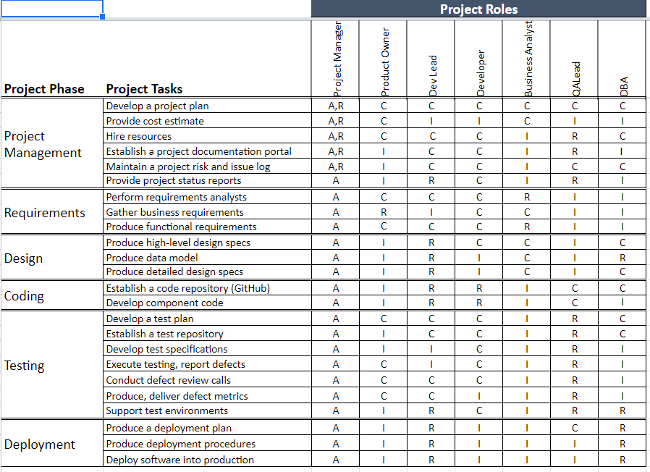

# Project Plan

This section will include a summary of the project plan, including a schedule of activities and resource requirements. Indicate, the team will follow the Agile development methodology.

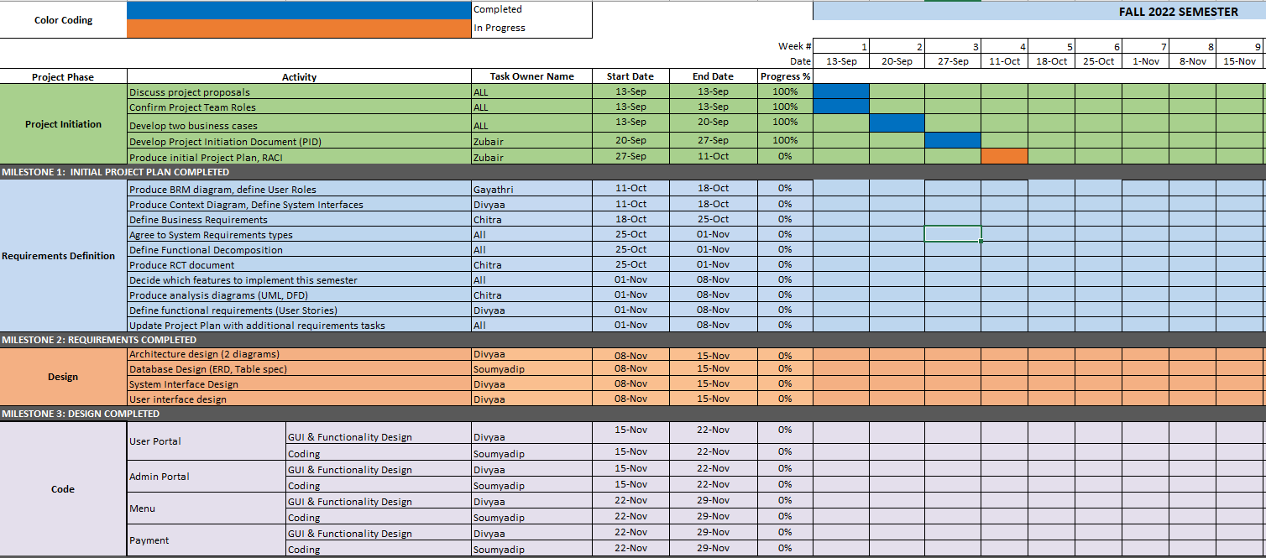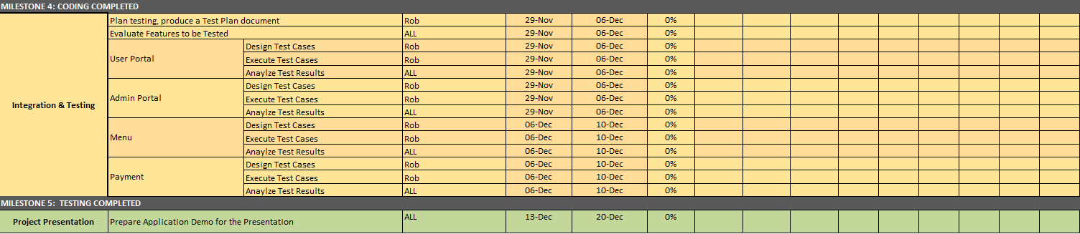

Milestones:

MS1: Initial Project Plan (10/11/2022)

MS2: Requirements Completed (11/08/2022)

MS3: Design Completed (11/15/2022)

MS4: Coding Completed (11/29/2022)

MS5: Testing Completed (12/10/2022)

# Project Controls

All of the project aspects will be in English( with respect to meetings , project documentation , project communication)

Project manager will organize meetings frequently and also any time required.All the team members has to complete their assigned work within a week

In case if any of the team member does not attend the meeting , then according to the concept of discussion , project manager will reschedule or split the meeting

Important concepts, decision making and team work management will be discussed and finalized in the meetings according to everyone’s opinion

Weekly meetings and the project phases will be maintained by the project manager and also the track of deadlines will be ensured by the project manager

In some circumstances whatsapp will be used to share the critical information regarding the project and also to upload any document , usually google drive or email will be used.

# Communication Plan

This section will include how stakeholders will be communicated with during the project and how frequently. This should include a note on where to find the Communications Plan if you have one.

| Stakeholder | Frequency | Type | Purpose |
| --- | --- | --- | --- |
| Professor | Daily | Email,Slack,Personal meetings | For approving Project implementation and advising regarding any potential issues |
| Banking | At Key Stage | Email,Phone,Personal meetings | ensuring the system and any other requirements |
| local Restaurants | At key stage | Email,Phone,personal meetings | requirements satisfaction |
| Project team | Daily | Email,Phone,personal meetings, slack | Maintaining Progress and ensuring that team is meeting frequently |
| End users | During testing and after release | Emails,attending workshops for website | Reviews |